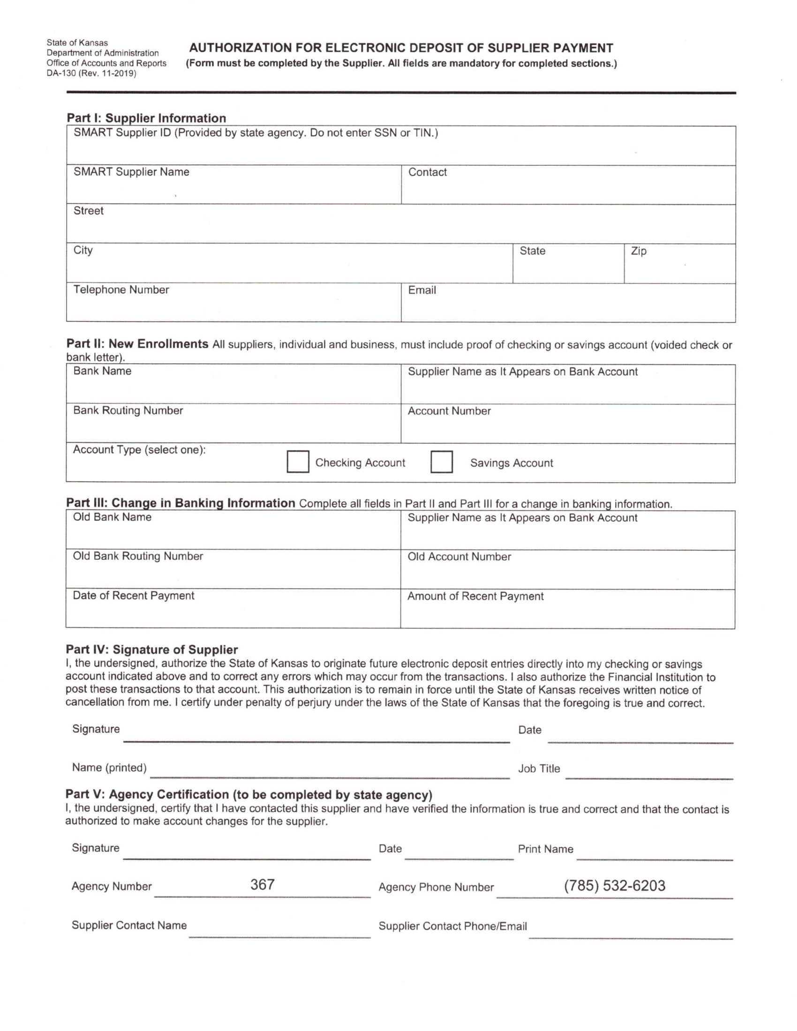 Gabhriel John

2675 NW Garryanna Dr. Apt. 8

Corvallis OR 97330

580-695-5529 [gabhriel.john@oregonstate.edu](mailto:gabhriel.john@oregonstate.edu)

Arvest Bank Gabhriel Barber

082900872 35774288

_X_

09-27-2023

Gabhriel John Graduate Teaching Assistant